Dunscore Community Council
Minutes of Meeting.
Monday 23rd February 2026 @ 8pm in Glenriddell Hall
Present:- Keith Harvey, Carrie McFadzean, Joe Cook, Brian Johnston, Cath Duncan, Andi Martin, Caroline Waugh, Kate Duffin, John Mcintyre, Allan Todd, Peter McFadzean
Apologies: - Katherine Elicott, Lesley Ross, Graham Walker
- Minutes from last meeting. Meeting from the last meeting were not received by the committee. A copy of attached here
The proposing and accepting of the minutes will be held over to the next meeting to allow the committee time to read them. If there are any matter arising from the minutes we will address them at the next meeting also

- Chairman’s report
(Copied from original script written by Keith Harrvey)
Since our last meeting in December, there have been several changes to our office bearers.

Brian has formally assumed the role of treasurer, following a structured handover from Joe. We extend our sincere thanks to both for ensuring a smooth and seamless transition.

I have been nominated and have accepted the position of chairperson. I would like to express my appreciation to Carrie for her dedicated service over the last two years in this role. Allan continues to serve as vice chair and Andi remain as secretary. My thanks go to them both for their ongoing commitment and hard work.

I would also like to acknowledge all committee members, both longstanding and newly appointed, for your continued contribution and commitment to the Community Council. Your voluntary efforts are essential to the work we carry out on behalf of the community.

In recent months, we welcomed a presentation from the energy company behind the proposed Dalmacallan wind farm. The session was both informative and constructive providing valuable insight into the proposals.

We are currently preparing to support a campaign, led by our Pre-school Manager and Primary School Head Teacher, advocating for the introduction of a 20 MPH speed limit within the village. Dumfries and Galloway Council has been implementing similar measures across the region, and inclusion in the programme would represent a significant enhancement to road safety in Dunscore.

In June, we will invite applications from local groups and organisations for this year’s allocation of wind farm funding. This funding round continues to provide meaningful support to the many excellent groups and clubs operating within our community.

Our programme of community events will also continue throughout the year. The next event will be the annual Easter Egg Hunt on Easter Sunday for preschool and primary aged children, fully funded by Dunscore Community Council. Later in the year, we look forward to organising Bonfire Night celebrations and, subject to arrangements, the return of the Santa Run.

As always, the Community Council strives to represent the interests of our residents. While some matters are within our capacity to resolve and others remain beyond our direct control, we remain committed to advocating on behalf of the community wherever possible.

I look forward to continuing to serve Dunscore throughout 2026 and to working collectively to build on the positive progress already achieved.

From this report, comments were made
- by Andi – we have already approached the council to reduce the village speed to 20 MPH and will forward anything we hear on to the other parties.
- By Carrie – we are still looking for an Easter Bunny volunteer – Keith said he would do this

- Treasurers Report
DCC Admin account £1399.46
Gardening Group £726.90
DCC Contingency Fund £2999.66
Blackcraig Windfarm £300.00
Dalswinton Windfarm £0.00
Harestanes Windfarm £3549.00

- Police Report –.
The requested speed checks were done in February. No cars were found to be speeding. They were doing another set of speed checks last week. We are still awaiting the results.

From the February police report, the only thing for Dunscore was 1 person was charged with a firearms offence.

From the December meeting, a request for information on Neighbourhood watch, there is one in Milton, Caroline will investigate this further and come back to us.

- Any other Business
- A presentation by the Save our Hills
A presentation was made by the Save our Hills group on the proposed windfarm at Damacallan, and the environmental impact it will have on the local environment.
A request was made to get a copy of the presentation, which the council is awaiting. An email of thanks and apology for the disturbance at the end of the meeting has been received.
- Council Insurance for Resilience – Andi – we now have specific insurance from the council for any activities which are relating the community resilience.

- Tree Planting for Twinning Association – Brian – the twinning association will be planning a tree planting in the play park to celebrate the twinning association – it is being done on the 21st March 2026

- Training for councillors – a team’s training session for anyone to attend
  - Treasurer – 23 February
  - Chair and Secretary – 3rd March – Andi attended this one
  - Windfarm Grants – 7th April
Some of the documentation and responsibilities were ran through at the training – Andi will share them with the council members and discuss them at the next meeting

- Knarie Windfarm presentation – 26th Feb – Glenriddell Hall – meeting was cancelled when Andi checked with the hall

- Feedback from last meeting’s questions – Andi – we received feedback form Force 10 who presented at the last meeting
  - What is the site area in Hectares?
The main site (excluding access areas) is 945 Ha.
How much concrete each turbine base would require?
We estimate that a 180m turbine would require 1,140 cuM concrete per turbine. A 200m turbine would require about 1,350cuM. This does however depend on ground conditions at each turbine. A single concrete truck takes about 20cuM of concrete.
  - Does a local energy discount scheme (LEDS) apply to the site?
We can offer a Local Energy Discount Scheme out of the Community Benefit fund if that is what communities would like the community fund used for. The further it goes and the more households it takes in, the smaller the discount could be. This is also dependent on the installed capacity of the project and therefore the size of the Community Benefit pot.
  - Could a LEDS apply to community groups in the area instead of residents?
It’s something we could consider, although we can’t say at this stage if it’s possible. We will raise with RES who is running the scheme.
  - What is the highest position of a turbine is on site?
For the 16 turbine scoping option, the highest turbine is on the 403m contour. For the 17 turbine scoping option, the highest turbine is on the 405m contour.
Can you reproduce the photomontage without any clouds?
We would advise against altering the photomontage to remove the clouds as this would be contrary to NatureScot ‘Visual Representation of Wind Farms: Guidance’. We can, however, print and send a copy of the existing photomontage (A1) as this will present a clearer image than when viewed on a small screen. If you would like us to do this, please advise of your preferred name and address to send this to.

- Glenkens Presentation – Brian – Brian will be attending a presentation on behalf of the community in Dalry and will feedback at the next meeting. He also mentioned that there are funds available for groups to apply for.

- Community Council ordinary elections – 3rd October 2026 – all stand down at AGM – posters have been put up and will be added to social media and the website in due course

- Bonfire 2026 – 1st November – Carrie / Keith – this is the last day under the current licence we can hold it – Keith and Carrie to sort out bonfire committee

- Community Council Website - Andi - we can now update the website with meeting notes and agendas – if anyone wants anything on there please let Andi know.

- We have had a request from Carrie to add planning information into every meeting –
The link for all the planning decisions is https://eaccess.dumgal.gov.uk/online-applications/search.do?action=weeklyList
Andi checked the planning and the following came up for this area
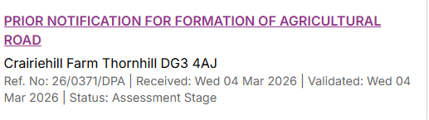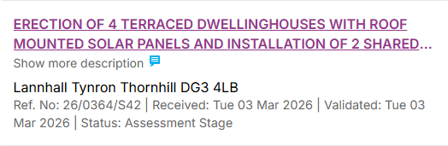
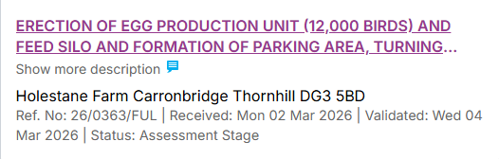
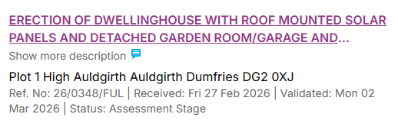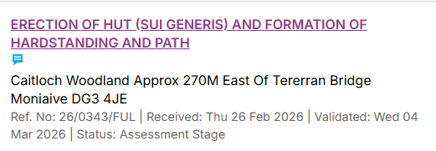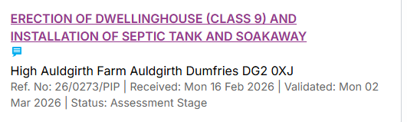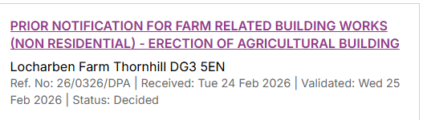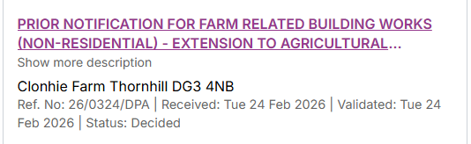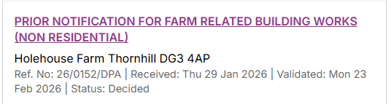
- Keith asked if he should ask the other windfarms in the area to come to meetings and do presentations and the consensus was yes.
- It was raised should we cap the amount that groups can apply for from the Windfarm funds. It was agreed that we should keep it that the council decides and that no cap is put in place

- Dates of next meetings
- 18th May 2026
- 29th June 2026 – Windfarm Grant Meeting
- 10th August 2026
- 21st September 2026
- 2nd November 2026 – AGM and new committee chosen

