Dunscore Community Council
Minutes of Meeting.
Monday 1st December 2025 @ 7.30pm
Present: - Carrie McFadzean, Joe Cook, Andi Martin, Alan Todd, Laura Creaney, Peter McFadzean, Caroline Waugh, Kate Duffin, Keith Harvey, Katharine Elicott, Lesley Ross, Brian Johnston
Apologies: - John McIntyre, Graham Walker

- Meeting note from the last meeting were proposed by Kate and Seconded by Keith and accepted

- Matters arising from last meeting. Nothing.

- The meeting was started with a briefing from Brian on Glenkens

  - He explained Glenkens managed a lot of the funding from the windfarms in the area
  - He ran through the last meeting notes ( copy attached to this email )
  - We get £2k a year from Glenkens themselves, the rest of our funding is from Foundation Scotland

- Treasurers report –
Dunscore Community Council - £1632.66
Dunscore Garden Group - £176.90
Tom Carrick Legacy - £2112.51
Blackcraig Windfarm - £2000.00
Dalswinton Windfarm - £6300.00
Harestaines Windfarm - £4099.00
As this is the AGM,. Joe all compiled the annual accounts which have audited by Caroline Rae.
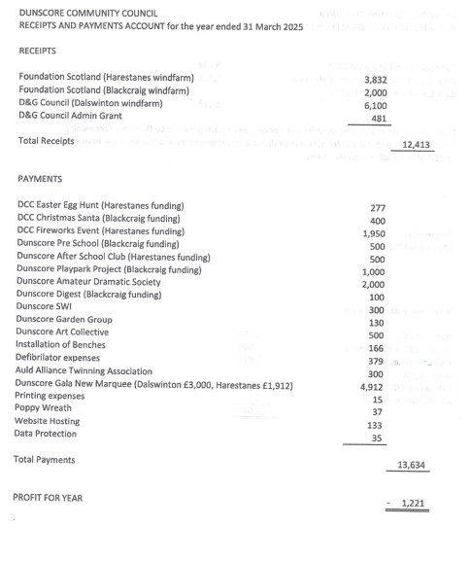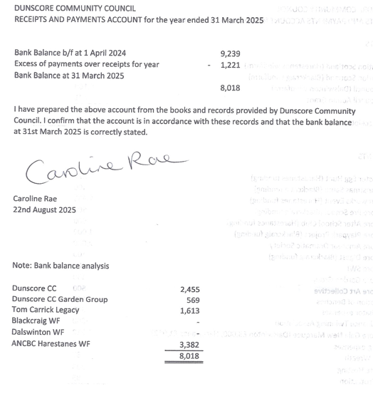
Currently the main duties are the completing of the forms and documentation for the windfarm grants.
- Police report – bit of activity this period – detailed not referred to on the crime report. Expect that the report will be updated ready for the next meeting. Carrie will try and get Eddie Hewson to the next meeting

- Chairpersons Report – we are now holding the 3 annual events in the village – Easter Egg hunt, Bonfire and the Santa Run. All events are well organised, stewarded and well attended.
We have co-opted 2 new members – Katharine and Lesley, Joe is still doing the treasurers role until Brian fully takes over. This year our secretary Andi was in a serious accident but is now back. Thank you for everything he does.
This year we tried to look at affordable housing in the area and got councillors and strategic housing involved. We looked at what Sanquhar had done but the council did not have the local communities support so was unable to move this forward.
We also have the annual round of funding grants from the windfarms and were happy to support all the groups who applied in some part.
We have a new head at the primary school – Siobahn Jones
We also have got involved the Glenkens group with Andi and Brian attending on behalf of the council.

- AOB –
  - Police Online Training – 5th November 2025 – 7pm
Police Community Council dial in
On teams
Meeting ID: 369 873 566 205 83
Passcode: nF6un2gr
This meeting will be held by Sergeant Callum Dalgleish-Little.
Any community council members can attend – just join via teams

  - Remembrance Sunday
Peter is to lay the wreath on behalf of the council – he will liaise with Rev Mark as to the timing of the event
  - Santa Run – 6th December 2026 at 6pm
Keith is driving the sleigh – Sandy and Carrie are Mr and Mrs Claus.
Laura has costumes, Carrie will get the Selection boxes
We need 2 stewards in high viz for front and behind the sleigh
Keith has the generator
John will provide the PA system
Carrie has a playlist of xmas music
We will finish at the pub with Andi opening the pub from 6pm

  - Village Xmas Tree
Peter will put the tree up
Keith will source a tree
Going up in time for the santa run

  - Scottish Government Network Event
Scottish Community Councils Team at the Scottish Government to an online networking event specifically aimed at rural and island community councils which will be hosted by Stronsay Community Council. – Andi will attend and feedback at the next meeting

  - Council Conference Pack
https://padlet.com/communitycouncils/resource-library-for-community-councils-across-dumfries-and--yz8n2qx5xzlz4jnc
the conference pack can be found here – just click on the link

  - Community Resilience Training – 12th November 2025 between 6.30pm and 8pm
Online on teams
Details to be circulated at a later date

  - Proposed Windfarms and Power Cables
We have a presentation on the proposed windfarms and power cables that are being planned for the local area. The presenters will produce an information pack for us which will be shared as soon
as possible

  - Rab spoke about the issues with traffic speeding through the village and asked can the council anything about this. Andi said about a doing a community speed check which Alan said was done previously a few years ago. Carrie said we would hold a meeting about this subject where we would get the council and police plus the public to attend.

The dates and times for the meetings for 2025/6
1st December 2025
12th January 2026 – Windfarm Meeting – In Glenriddle Hall
23rd February 2026
30th March 2026
18th May 2026
29th June 2026 – Windfarm Grant Meeting
10th August 2026
21st September 2026
2nd November 2026 - AGM

